POHYBOVÉ AKTIVITY

domácí i venkovní

[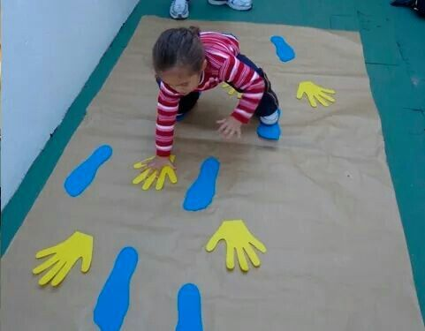](https://i.pinimg.com/originals/af/49/5f/af495fe2bfcf41a70f2951ccd7b0a4b9.jpg)

[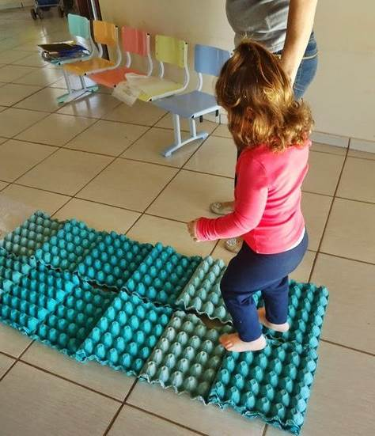](http://crechecarmen.blogspot.com.br/2014/05/tapete-sensorial-maternal-i-prof-gisela.html?m=1)

[[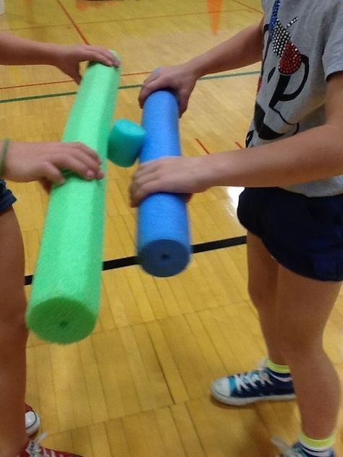](http://physicaleducationandmore.blogspot.ca/2012/08/responsible-personal-and-social-behavior.html) pěnové válce lze venku nahradit klacíky a šiškou](http://physicaleducationandmore.blogspot.ca/2012/08/responsible-personal-and-social-behavior.html)

[[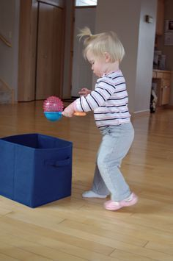](http://twostepsbehindsixlittlehands.blogspot.com/2012/01/its-how-toddlers-are-content-for-long.html?m=1)](http://physicaleducationandmore.blogspot.ca/2012/08/responsible-personal-and-social-behavior.html)